kimPuppies – How To
The following is made assuming Wednesday morning is when filming takes place. Please be sure all prints are ordered before noon on Thursday.

Making the Videos*

*Note: I will be setting forth the way I make the videos in Final Cut. This is not the only way nor the way that will work best for you. Also I have found it best to upload the videos to Vimeo immediately after exporting.

Before beginning, go to Petland’s website and watch a few examples

In the end, the timeline should look very similar to this:
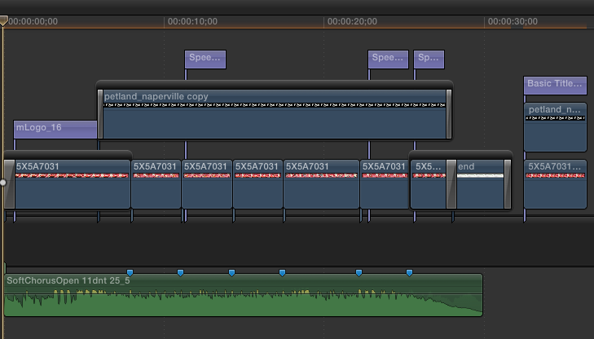

Step 1: Import footage of puppies shot earlier into a new Library in Final Cut. Also import all 4 media items from ‘puppies’ folder in the ‘Movies’ folder of this computer

Step 2: Create a new 1280 x 720 project and name it the number of the dog

Step 3: Choose clips of the following lengths and place them on timeline (see below)
Clip 1 is 7 seconds 28 frames long Clip 2 is 3:05 Clip 3 is 3:07
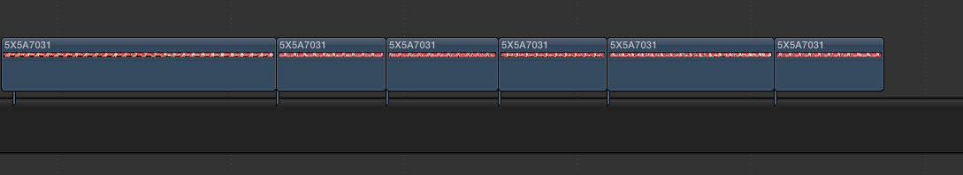
Clip 4 is 3:04 Clip 5 is 4:24 Clip 6 is 3:05
Step 4: Hero shot/Rockstar moment, freeze frame, and size (see below)

- Find the shot where the puppy looks directly at the camera
- Select several frames (at least 10, probably no more than 29) and place on timeline
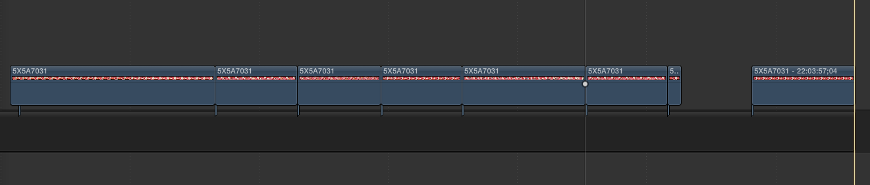
- Generate freeze frame and place separately from other clips. This will be used later as the exported still image.

-Select everything but the freeze frame then scale everything to ‘67%’, then change the spatial conform feature to ‘None’ in the box on the right side of Final Cut in ‘Video’

Step 5: Opening and closing shots (see below)

- Apply a 0:19 fade up from black transition to Clip 1
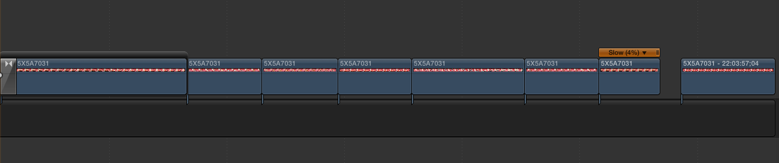
- Slow speed of final clip so its length is 2:18

Step 6: Place music and logo and ending graphic (see below)

- Place music (SoftChorusOpen 11dnt 25_5.mp3) on timeline starting at 0:00

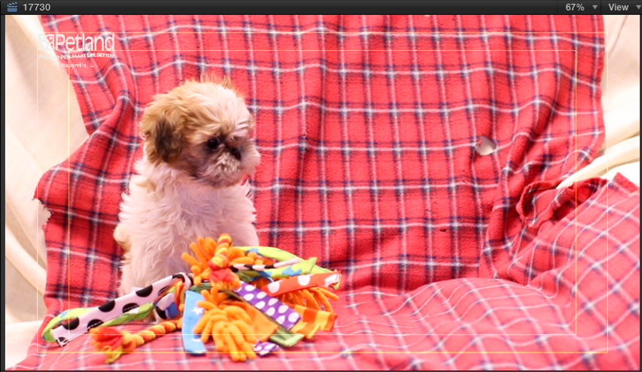
- Place “petland_naperville copy.png” on timeline above clips starting at 5:26 (end where final clip ends) with a :07 dissolve on each end and drop the opacity to 89% and place the logo so it matches the screenshot:

-Place “end.png” after final clip. Duration 3:22. Add :11 fade to black

-Create :13 second cross-dissolve between final clip and “end.png”

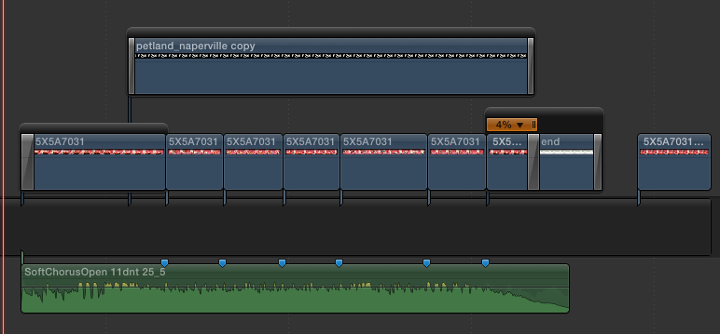

Step 7: Placing opening logo

- On the lower right in Final Cut, Select the ‘T’, choose ‘mLogo’ from the submenu, then click and drag ‘mLogo_16’ onto timeline starting after the fade up at the beginning.
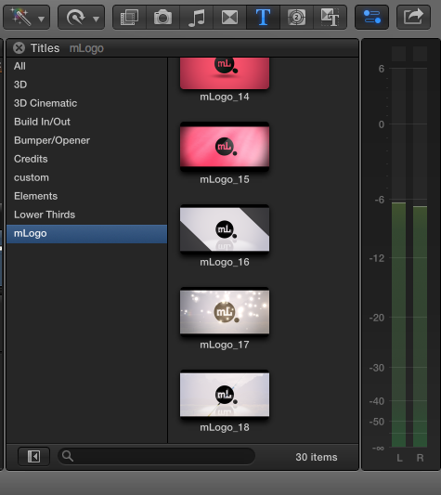

-Adjust length of ‘mLogo’ so it ends where ‘petland_naperville copy’ starts (5:07 total)

- Adjust parameters of the ‘mLogo’ so it matches the screenshot below
-Use “petland_naperville_green” as the source of mLogo_Effect
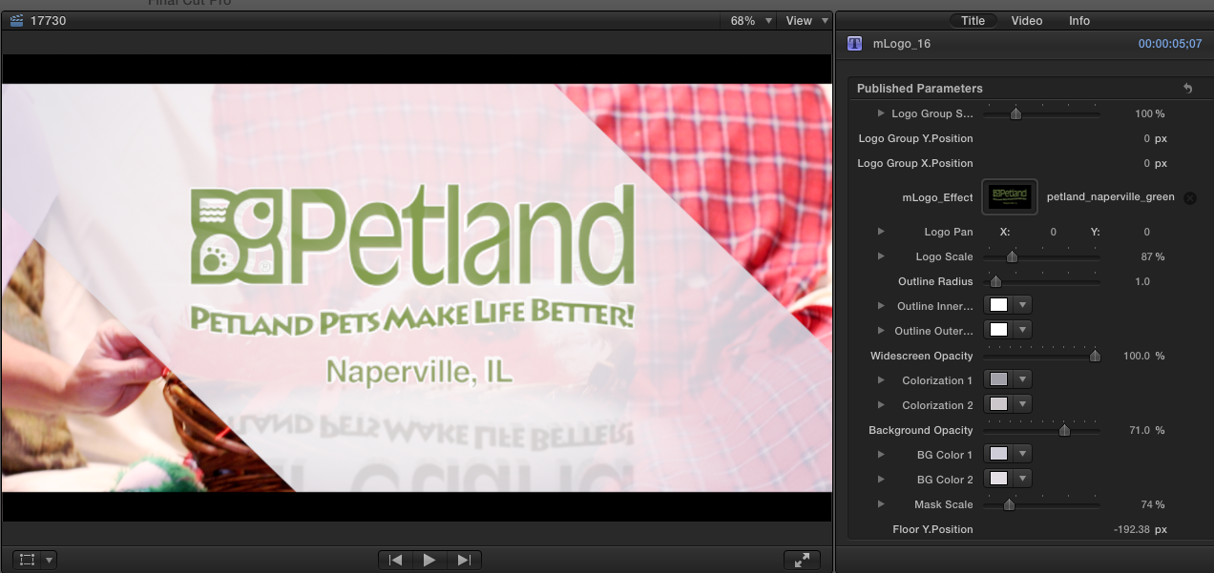

The timeline should look similar to this:

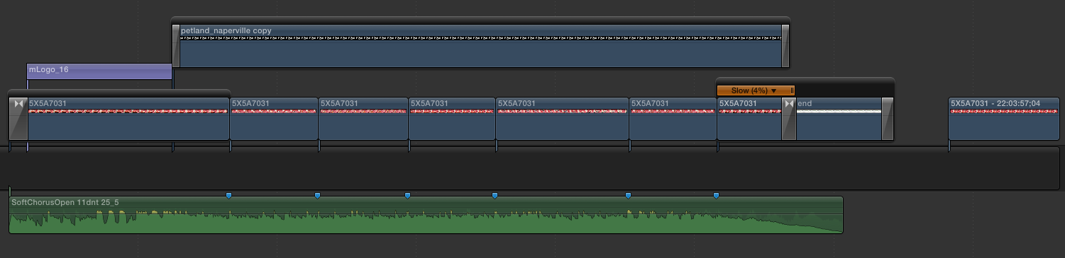

Step 8: Speech Bubbles. You’ll need to place 3 speech bubbles total. 2 speech bubbles and 1 thinking or viceversa. You’ll have to get creative with the content. One of them must be on the final clip. See previous videos for ideas on content. The font to use is called “PuppyBellies”

- On the lower right in Final Cut, Select the ‘T’, choose ‘All’ from the submenu, find then click and drag ‘Speech Bubble’ onto timeline
-Make the outline color the same green as the ‘petland_naperville_green’ logo. The size, height, and width will vary depending on what the clip is like.

*Notes on placement: Place the speech bubbles where they will not be covering any of the dog’s face and try to avoid covering the logo in the upper left corner.
**Note on the content of the final speech bubble: The content can be repeated and tweaked slightly as many times as need be. However, avoid identical content for dogs of same breed. For example, don’t have 3 French bulldogs with “Come see me soon!” You can however, have “Come see me soon!” “Come and see me soon!” and “Come see me today!”

Again, see previous videos for ideas on content and placement

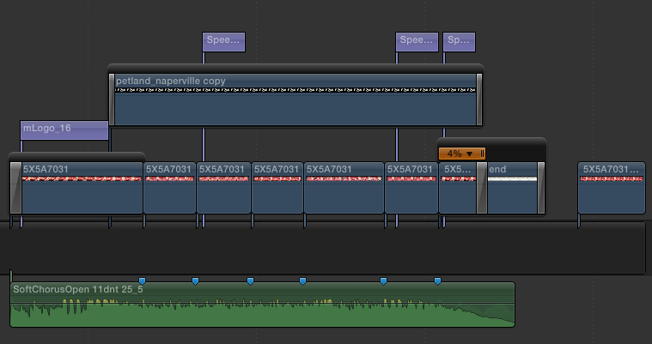
The timeline should look similar to this, with the position of the first two bubbles being relative:
Step 9: Filters
- Do some minor color correction to the footage
- I have found applying a ‘Sharpen’ filter with a strength of 4 and applying it to the final clip and the freeze frame makes it look better no matter how in focus the original

Step 10: Check and export video

- I usually skim over the timeline to make sure there are no obvious errors before exporting
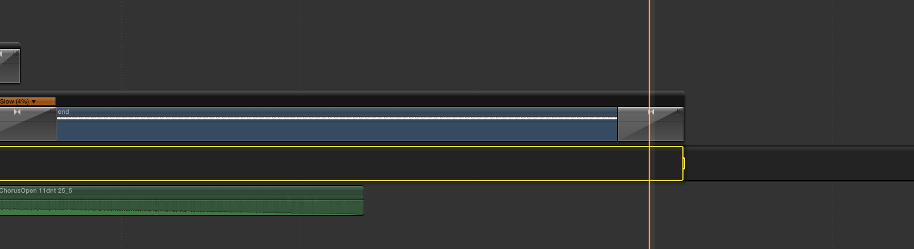
- Place the time indicator line at the end of the video segment of the timeline and make it the out point (hit ‘O’ on the keyboard). It looks like this:

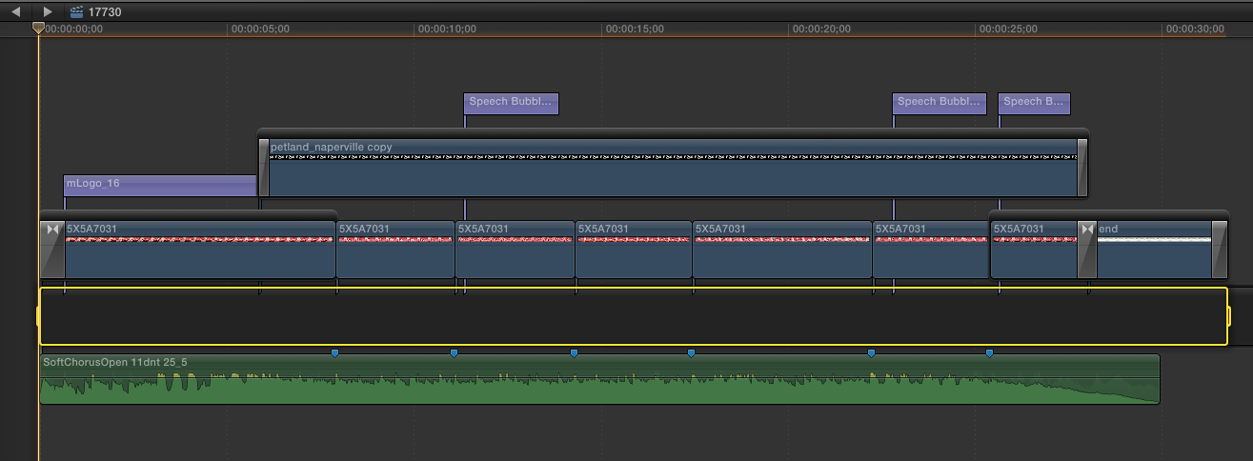
- Ensure the in-point of the selection starts at the beginning. (The yellow selection area should start 0:00 and end when the fade out of ‘end.png’ ends. The whole selection looking like:

- Export video and save in a folder

Step 11: Finishing still frame
- Copy and paste “petland_naperville copy” and paste it above freeze frame in timeline
- Create text and make the still frame look like this:

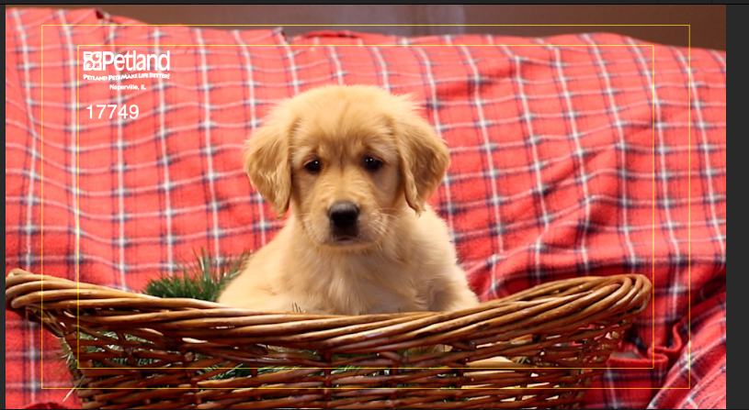

*Note: keep the logo and number fully inside both lines. When the photos are printed everything that is not fully inside the lines will get cut off. If you need to move the logo and number to another side so its doesn’t overlap with the puppy, that’s fine. If you need to outline the number in black to make it stand out against a white or similarly colored background, that’s fine

Step 12: Export by first placing current time indicator somewhere over freeze frame like so:

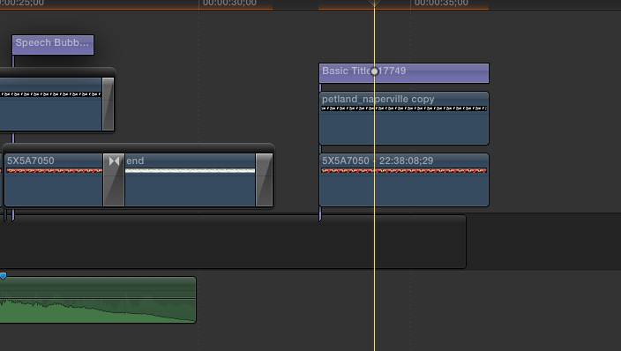

Then, hit ‘File” then ‘Share’ then ‘Save Current Frame’ and save jpeg in a folder

Repeat process for all puppies. When finished check the still frames to make sure the numbers match the puppy.

Continue for web instructions

Upload pictures to Walgreens and order

Step 1: Got to Walgreens.com, click sign-in in the upper left login info:
petlandnaperville@gmail.com
puppies1234

Step 2: Upload photos
- Put cursor over orange photo tab and hit ‘upload’
- Click ‘upload new photos’
- Upload to a new album, album titled today’s date (will be automatically selected)
- Hit ‘select photos’ and choose the latest round from the folder on the computer
- Wait for upload to finish and proceed to step 3

Step 3: Order prints

- When uploads are finished click ‘Add uploaded 4x6 prints to cart’
- When prints are added, click ‘Go to Cart”

Step 3B:
- Make sure quantity of glossy prints is accurate
- Click ‘Proceed to Checkout’

Step 3C:
- Make sure pickup location is 1779 Sequoia Rd Naperville, IL 60540
- Make sure pickup time allows for prints to be picked up by Petland by 2:00pm on Thursday which means prints should be uploaded and ordered by noon on Thursday.

Uploading pictures to Dropbox

*Note: I prefer doing this directly online as it saves me a step later.

Step 1: Opening the Dropbox Folder
- In the upper right of the computer screen, click the box icon, then the Globe icon.
- Scroll down to the “Petland Naperville Pet Photos” folder and open it
- open the ‘photos’ folder

Step 2: Replacing photos
- Delete all photos in the folder
- Upload the most recent round of puppy photos

Petlandnaperville.com Web portion

Part 1: Fetch

Step 1: Open Fetch and when time has passed, click ‘Try’
- Enter this and click ‘Connect’:
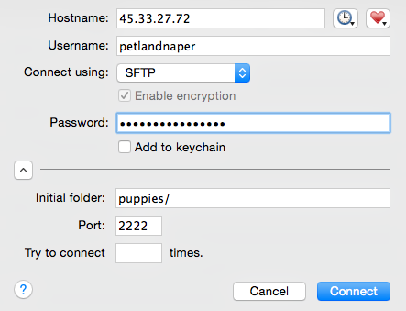

Password: Misty277#1

Step 2: Open a new window of the folder where all the new photos are located
- Highlight all photos, then click and drag into Fetch

Leave Fetch open for later

Part 2: Vimeo

Step 1: Login to Vimeo using this information:
Carl@petlandnaperville.com
Petland1

Step 2: Upload videos (in order is helpful) Again, I find uploading videos after exporting is best.

Leave Vimeo up for later

Part 3: Putting it all together

Step 1: Click this link, http://petlandnaperville.com/wp-login.php?redirect_to=http%3A%2F%2Fpetlandnaperville.com%2Fwp-admin%2Fpost-new.php%3Fpost_type%3Dpet_media&reauth=1 and login using:

Login: trueproductions password: success85
Step 2: On sidebar of wordpress click, ‘Pet Media’ see below
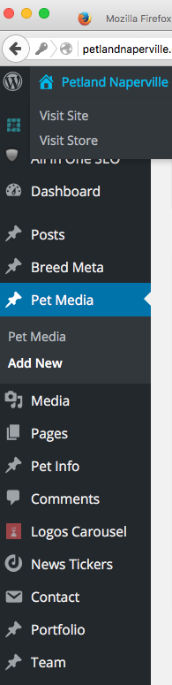

I call the page you will
land on the
“Pet Media
Homepage”

Step 3: In the upper-left of the page, click the blue “Add New” square
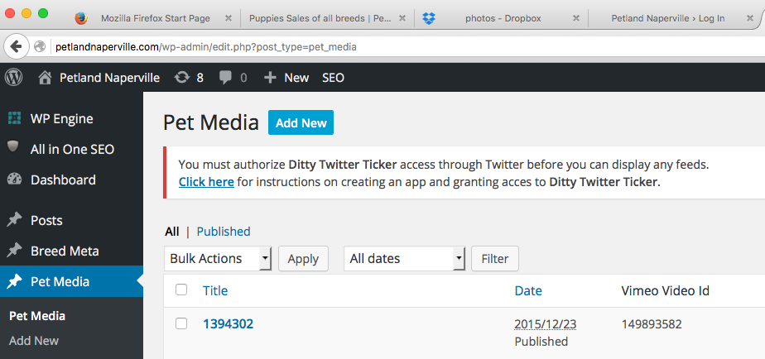

Step 4: Fill in lines lines 1- 3, the example used here is for a Siberian Husky, number 17755
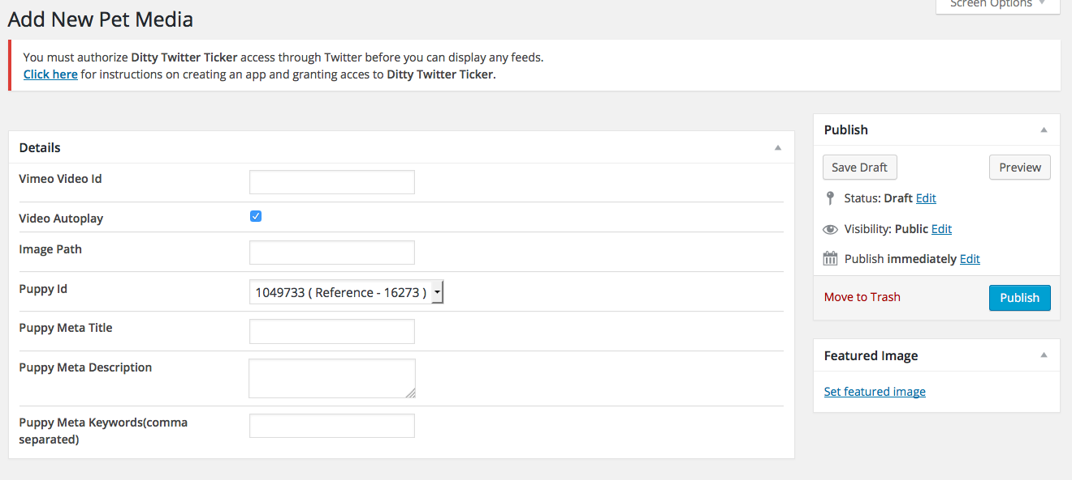
Line 3
Line 1

Line 2

Line 1: The Vimeo ID is the number located after the slash for the puppies Vimeo video

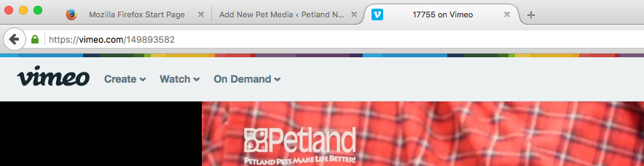

- Copy the numbers only (in this case 149893582) and paste them into Line 1

Line 2: The Image Path is the web address from Fetch

- In Fetch, right click on the appropriate puppy number and click ‘Copy Web Address’
*Note it must be ‘Copy Web Address’ If it is not available, ask for help. Click on webview to make sure that you have working links. If not, connect it to petlandnaperville.com/puppy-sales

- Paste into Line 2, then type in text after ‘.com/’ so it looks like this
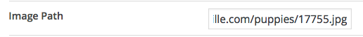
The complete text will be like this:
http://www.petlandnaperville.com/puppies/18555.jpg

Line 3:
- Click the arrow and scroll all the way down to find the appropriate ID using the reference number.

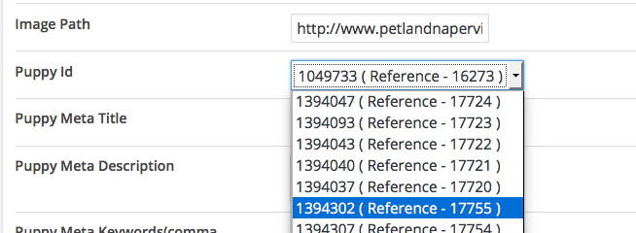

If the number isn’t there, go into general settings and “purge all caches”

Step 5: When the entry looks like this, click the blue ‘Publish’ square
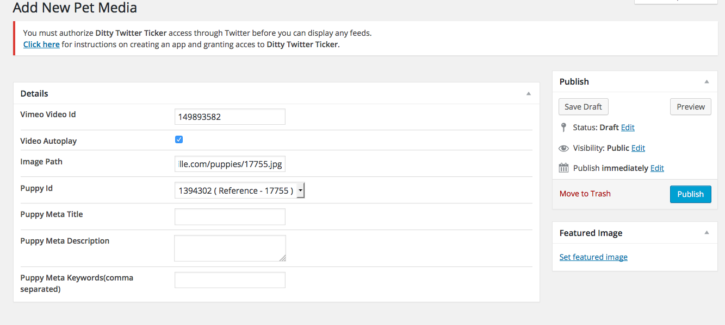

You can check to see if it worked by going back to the Pet Media Homepage and seeing below,

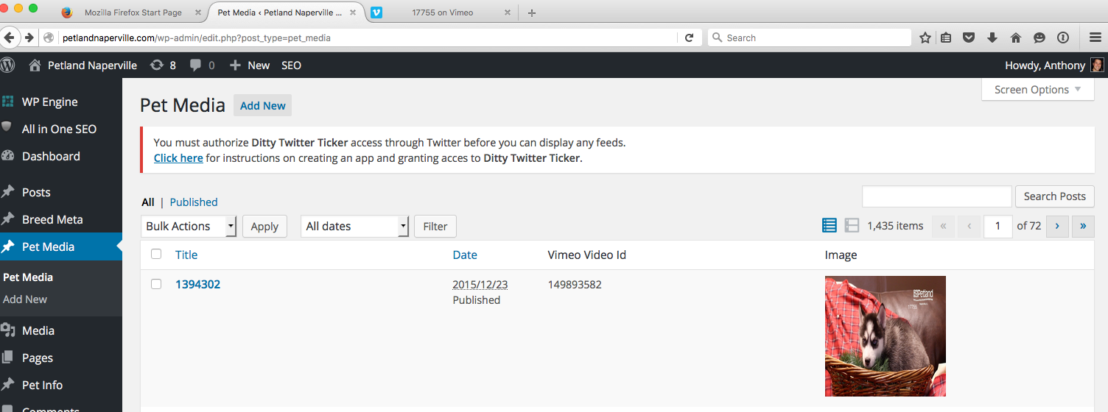

If you don’t see this, check back to make sure you have all three lines properly filled out,

When complete, hit the blue “Update” square, see below

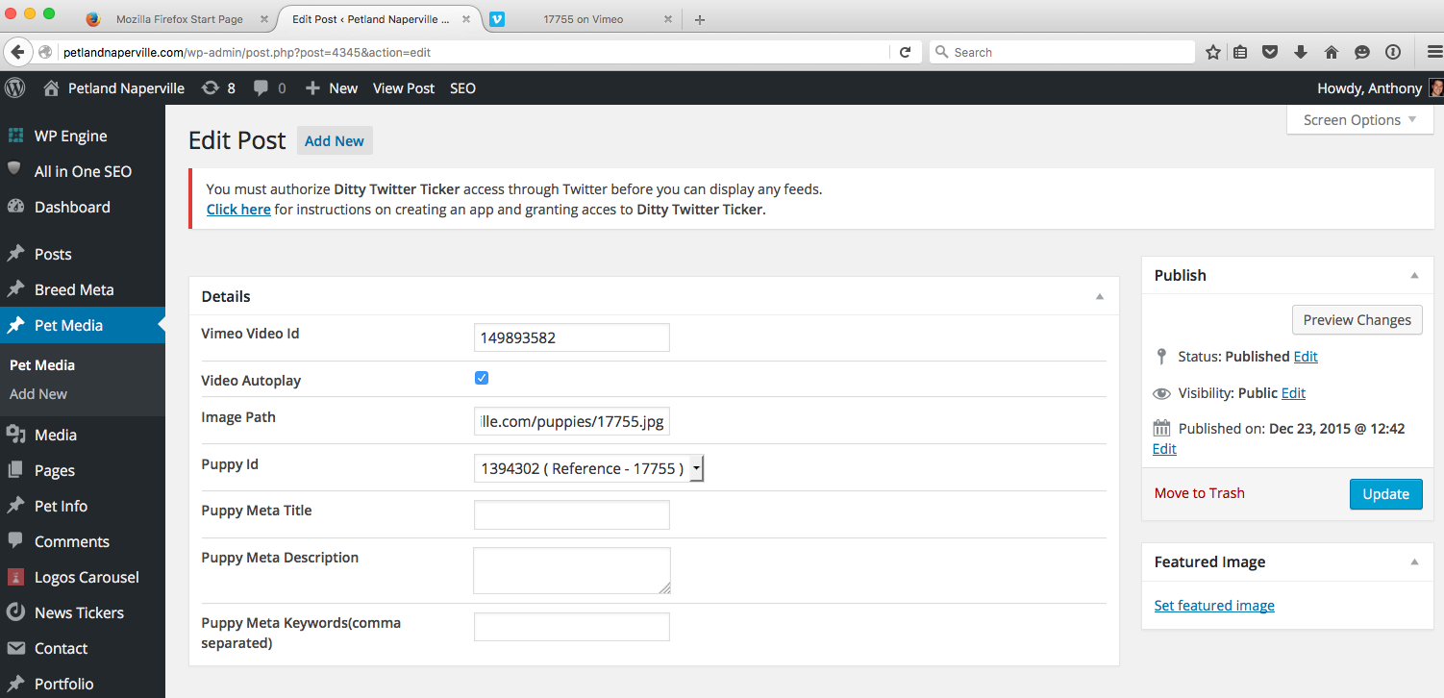

Step 6: When everything is completed and looking good: I traditionally take the paper that had the list of puppies on it given to me at the shoot, make it into a paper airplane, then try and throw it so it lands perfectly in the trash. This step is optional, but I highly recommend it.

