How to Access Pirello Footage

Go to this website- http://pirrello.com/login/
You should be met with this screen 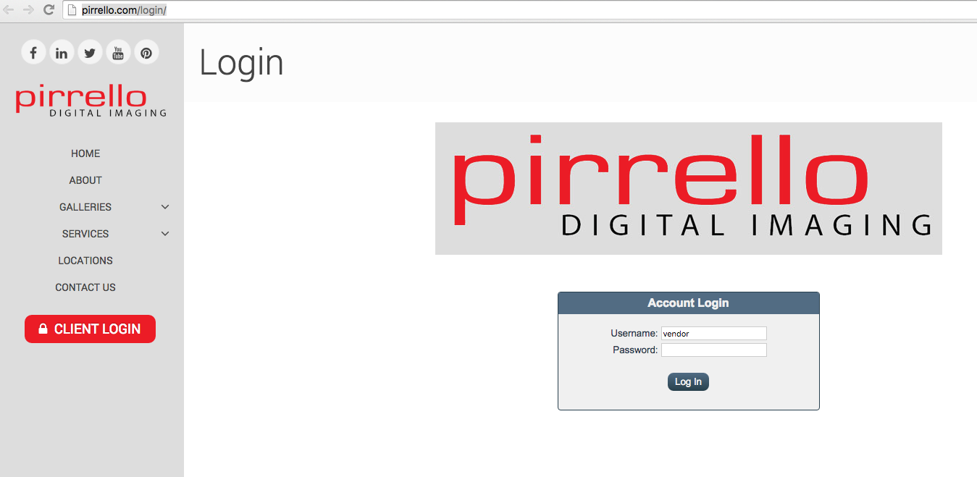
- The username is vendor, the password is upload (no caps)
- Once you’ve logged in, you should see this screen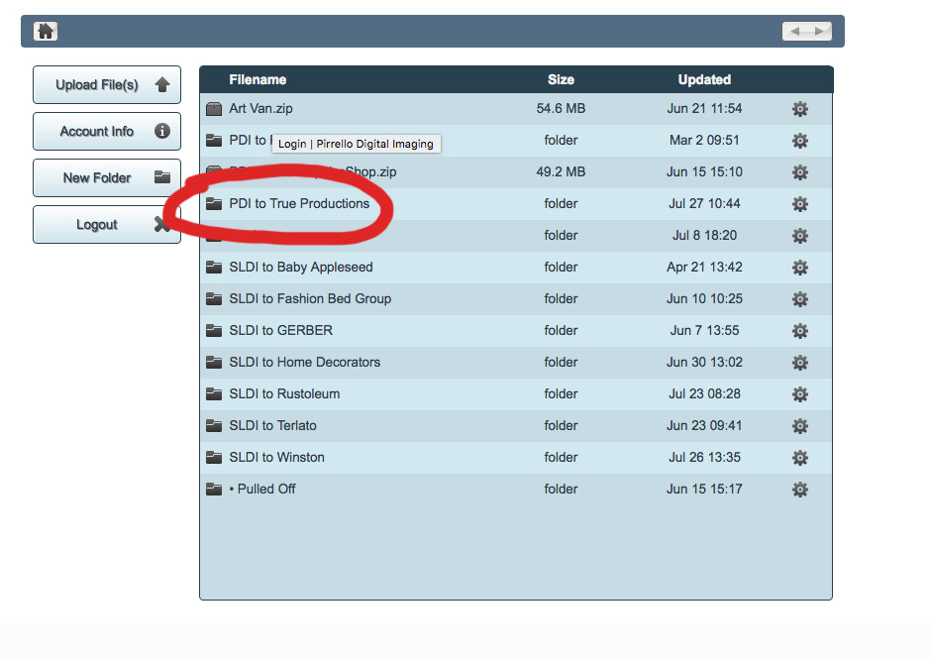
- Click on the PDI to True Productions Tab, then this should come up 5. 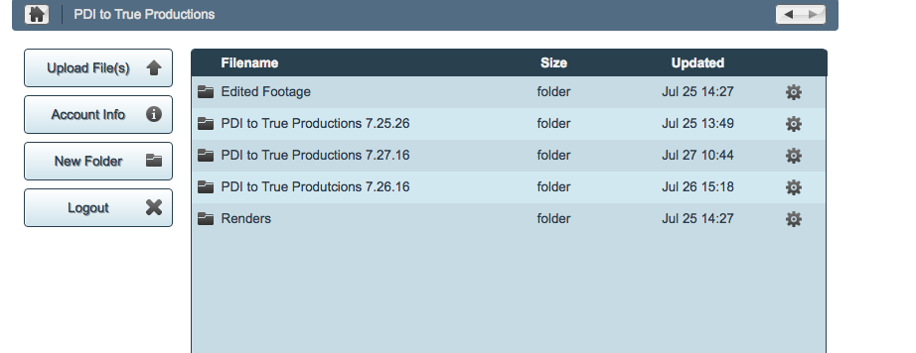
- Click on the folder that corresponds with the project/ date you need to work on. I’ve clicked on the 7.27 folder for an example.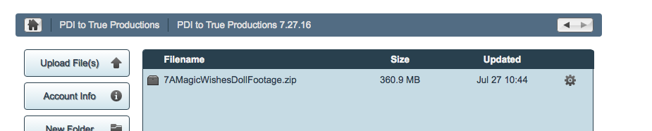
- Finally, click on the video you need to edit that appears on the screen, it should automatically start to download.

- After it has finished downloading, find the folder you just downloaded from the “downloads” folder on your computer.

- Copy that footage, and create a separate folder in the project drive under pirrello digital imaging, inside of the footage folder, and name it whatever the product is called.

